**OBSTACLE DETECTION SYSTEM**

**Project report in partial fulfilment of the requirement for the award of the degree of**

**Bachelor of Technology**

**In**

**CST\CSIT**

**Submitted By**

Raj Priya Singh Enrolment No. : 12023002022113

Prince Kumar Enrolment No. : 12023002022133

Aditya Kumar Enrolment No. : 12023002023051

Kalpana Kumari Enrolment No. : 12023002022214

Aditya Kumar Enrolment No. : 12023002023052

**Under the guidance of**

Prof. Debanjana Datta Mitra

Department of Computer Science and Technology & Computer Science and Information Technology (CST & CSIT)



UNIVERSITY OF ENGINEERING & MANAGEMENT, KOLKATA

University Area, Plot No. III – B/5, New Town, Action Area – III, Kolkata – 700160.

**CERTIFICATE**

This is to certify that the project titled Obstacle detection system submitted by **Raj Priya Singh (University Roll No. 12023002022113), Prince Kumar(University Roll No.12023002022133 ),Aditya Kumar(University Roll No. 12023002023051), Kalpana Kumari(University Roll No. 12023002022214),Aditya Kumar (University Roll No. 12023002023052)** students of UNIVERSITY OF ENGINEERING and MANAGEMENT, KOLKATA, in partial fulfilment of requirement for the degree of Bachelor of Computer Science and Technology\information technology, is a bonafide work carried out by them under the supervision and guidance of Prof. **Debanjana Datta Mitra** during third Semester of academic session of **2023-2027.** The content of this report has not been submitted to any other university or institute. I am glad to inform that the work is entirely original and its performance is found to be quite satisfactory.

___________________________________

Signature of Guide

___________________________________

Signature of Head of the Department

**ACKNOWLEDGEMENT**

We would like to take this opportunity to thank everyone whose cooperation and encouragement throughout the ongoing course of this project remains invaluable to us.

We are sincerely grateful to our guide Prof. Debanjana Datta Mitra

of the Department of CST & CSIT, UEM, Kolkata, for his/her wisdom, guidance and inspiration that helped us to go through with this project and take it to where it stands now.

Last but not the least, we would like to extend our warm regards to our families and peers who have kept supporting us and always had faith in our work.

Raj Priya Singh

Prince Kumar

Aditya Kumar

Kalpana Kumari

Aditya Kumar

**TABLE OF CONTENTS**

**ABSTRACT.....................................................................…<PAGE NO> 1**

**CHAPTER – 1: INTRODUCTION............................................…<PAGE N0>2&3**

**CHAPTER – 2: LITERATURE SURVEY**

**2.12. GENERAL INTRODUCTION ........................................................<PAGE NO 4>>**

**2.2 SCOPE OF THE PROJECT ....................................................................<<PAGE NO 5>>**

**2.3 ADVANTAGES OF PROPOSED TECHNIQUE ..........................<<PAGE NO 5>>**

**CHAPTER – 3: PROBLEM STATEMENT**

**3.1.PROBLEM STATEMENT.....................................................<<PAGE NO 6>>**

**CHAPTER – 4: PROPOSED SOLUTION**

**4.1 SOLUTION...................................<<PAGE NO 7-11>>**

**CHAPTER – 5: EXPERIMENTAL SETUP AND RESULT ANALYSIS**

**EXPERIMENTAL SETUP AND RESULT ANALYSIS......................<<PAGE NO12-24>>**

**CHAPTER – 6: CONCLUSION & FUTURE SCOPE**

**CONCLUSION & FUTURE SCOPE.........<<PAGE NO 25>>**

**BIBLIOGRAPHY ..........................................................................<<PAGE NO.26>**

**Abstract**

This project presents the design and implementation of an Obstacle Detection System aimed at enhancing safety and navigation in autonomous vehicles and robotics. The system utilizes a combination of sensor technologies, including ultrasonic sensors, to detect obstacles in the environment. Data from these sensors is processed through a microcontroller, with algorithms designed to interpret the proximity, size, and nature of detected objects. The system is capable of real-time obstacle detection and provides alerts or initiates corrective actions such as stopping or steering to avoid collisions. This report outlines the system's architecture, the sensor fusion techniques employed to improve accuracy, and the software algorithms used for data processing and decision-making. The performance of the system is evaluated through a series of test scenarios, demonstrating its reliability and effectiveness in various conditions. The proposed obstacle detection system has potential applications in autonomous vehicles, drones, and mobile robots, contributing to the advancement of safe and efficient autonomous systems.

**1. GENERAL INTRODUCTION**

As per the definition of blindness, we mean the person without sense of sight. A blind person has no ability to see anything. While struggling for the different levels of comforts of the general population, we have reached to a point where we have started to completely ignore the people who are living a miserable life due to lack of vision. They face enormous challenges in their daily lives and hence end up living a dependent life. They experience a completely different life from the normal people and experience detached and uninterested conduct towards them for being physically disabled. They need other individuals for their movement from one place to another. Sight is the basic sense of life and therefore a person’s movement from place to place in this condition is a major challenge for the visually impaired . The target of this task , This project for the blind or visually impaired person will provide a gadget that is helpful to them as well as the persons who depend on any individual due to lack of sight. Third eye for blind task can be an innovation for the sightless individuals, it will help them to move from here and there and among different places with confidence by knowing the nearest obstructions while wearing the band which leaves the ultrasonic waves which inform the person with beep-sound or vibration. It can let the person who is not able to move and distinguish even snags due to lack of vision. They just have to put on the gadget as a band/bracelet or it can be adjusted on the dress on their body. As per WHO(world health organisation) 2.2 billion people suffer from vision impairment. They experience a lot of troubles in the daily lives. This device can be an innovation for the physically disabled or blind individuals. The people with physical disability used the common way that is white cane previously that was also efficient, but it had lot of limitations. Second approach is, having a pet ,like a dog ,though it is costly but is helpful .Therefore this task ,Third eye for blind will be developed as a moderate, very productive approach to help the blind person traverse with confidence and more interest. The device acts as an innovation for blinds which helps to solve all issues . At Present, enormous techniques and brilliant innovations are available for the physically disabledpeople, almost all of these devices have solved some of the issues for the sightless people but there exist many demerits like they require considerable measures of preparing and and high maintenance. The uniqueness of the proposed advancement is, it is fair for everyone, the total cost being under $20 or 1500 INR. In the market, no such devices are available that look like an item that can be worn with so much less effort, clarity. By increasing the usage of the gadget and the upgrading the changes in the model, it would definitely be profitable to the people with less or no vision at all. The basic mechanical gadget that is the strolling stick is manufactured so that it can be used in identifying stationary objects on floors, unbalanced surfaces, holes, steps using the basic mechanical matter. The gadget is fine, convenient but because of compact area it cannot be used for vast snag identification The device works like radar, orientation of the device uses the ultrasonic waves and collect them to note the altitude, direction or also velocity of that object. The separation among the object and person is assessed on the travelling of the wave. Nevertheless, all present systems advise the person about the closeness of the protest at a certain space in forefront or nearby the individual. The interesting aspects enable the unsighted person in distinguishing snags and grants him access to choose his path properly with no issue. This device can help the person in identifying any type of hindrance like a snag. For surviving the earlier stated restrictions this project work provides primary, productive,

customizable and effective solution to the visually impaired.

**2. LITERATURE SURVEY**

In the past few years, there has been innovations and development of various techniques and devices or gadgets guiding visually impaired people, thus towards attaining their independent or free movement around the surroundings without any other individual’s support. Few parameters are there but they are having some limitations and restrictions. D. Dakopoulos, N.G. Bourbakis, ”Wearable obstacle Avoidance Electronic Travel Aids for Blind; A Survey” proposed that a relative survey among mobile obstacle detection systems in order to inform the research community and users regarding the abilities of this project and regarding the innovation in adaptive technology for the sightless people. This study is based on different attributes and performance specification of this system that arranges them in categories, offering quantitative-qualitative analysis. M.A Ungar S[5]. He proposed methods for the unsighted people ofurban areas. But they didn’t consider the people who cannot afford equipments of high cost. This drawback overcomes in Third eye for blind. Ms Pooja Sharma[6]. She analysed that objects can be detected, but there are drawbacks in terms of angles and distance . On the other hand, third eye for blind has a wide angle for the detection which can be widened with respect to the range of the sensor. Hugo Fernandesc, Joảo Barroso”Blind Guide: an ultrasound sensor based body area network for guiding blind people” . The research introduces supportive formula for sensing obstacles for the sightless persons who generally take help of white-cane or the pet dog, thus for the detection of obstacles by using this device provides a proper solution to the blinds. Based on the Body Area Network of ultrasonic sensors that generate sound-based response, this solution is given. The Body Area Network can be inserted inside cloth fabric, emancipating sightless person from utilizing the seeing-eye dog or that whitecane . Today’s Innovative world is providing many solutions to the visually impaired for example; white-cane having a tip for assisting the movement of the blind people. The cane has different types used in today’s technological worldin the form of white cane, laser cane and smart cane. Dogs trained for this purpose are too expensive and unaffordable for certain people[9]. The study discovered [10] that the remote guidance system being very hard to move hence this device will act as most optimized version

**2.2 SCOPE OF THE PROJECT**

In future with the advancement of quicker response of sensors, like the usage

of top notch sensors it can be made highly useful and also the modules that one

needs to wear as a bracelet or on any other part of the body can be transformed

into a wearable clothing like a coat, so that it can be made fit for working and

there can be more advancement in this device for instance we can use piezeo

electric plates in the shoes of the user which can generate sufficient electricity

that the modules can run on.

**2.3 ADVANTAGES OF PROPOSED TECHNIQUE**

* Easy to Carry and Affordable for everyone
* By wearing this device they can fully avoid the use of white cane and such
* other devices.
* This device will the help the blind to navigate without holding stick which is a
* bit annoying for them.
* They can simply wear it as band or cloth and it can function very accurately and
* the only need a very little bit training to use it.
* They can sense the distance between the object and them by the sound and

vibration.

**3.PROBLEM STATEMENT**

In recent years, the development of autonomous vehicles and robotic systems has gained significant momentum, with increasing reliance on automated technologies for navigation and decision-making. However, one of the major challenges these systems face is the detection and avoidance of obstacles in dynamic and unpredictable environments. Traditional methods of obstacle detection, such as manual control or basic proximity sensors, are often insufficient in providing real-time, accurate, and reliable obstacle detection, particularly in complex or cluttered environments. This limitation can result in accidents, collisions, or failures in mission execution.

The problem addressed in this project is the need for an effective and reliable Obstacle Detection System that can detect and avoid obstacles in real-time, ensuring the safe operation of autonomous systems. The system must be able to handle a wide range of environmental conditions, varying object sizes, and diverse obstacle types. Additionally, the system must be cost-effective, lightweight, and scalable, making it suitable for integration into a variety of autonomous platforms, including drones, robots, and self-driving cars.

This project aims to design and implement a multi-sensor obstacle detection system that uses advanced sensor fusion techniques to improve detection accuracy and response time, ensuring optimal performance in real-world scenarios.

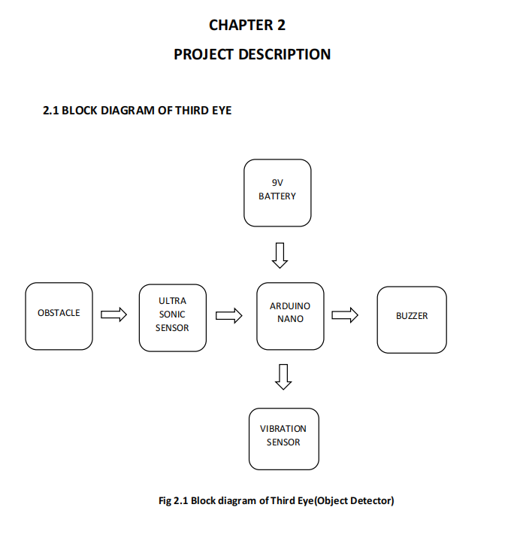**4.PROPOSED SOLUTION**

**4.1 BLOCK DIAGRAM OF THIRD EYE**

**4.2 ULTRASONIC**

**4.1.1 Introduction to Ultrasonics**

In recent times ultrasonic has been applied with considerable success in various fields of Engineering and medicine. It has also found was use in light industry (e.g. toy industry) agriculture and power engineering. In fact it is difficult to find a field of industrial endeavour for which ultrasonic energy has not been tried of suggested, if not put in actual use.

**Ultrasound** is an oscillating sound pressure wave with a frequency greater than the upper limit of the human hearing. Ultrasound is thus not separated from 'normal' (audible) sound based on differences in physical properties, only the fact that humans cannot hear it.

Although this limit varies from person to person, it is approximately 20 kilohertz (20,000 hertz) in healthy, young adults. Ultrasound devices operate with frequencies from 20 kHz up to several gigahertz’s.

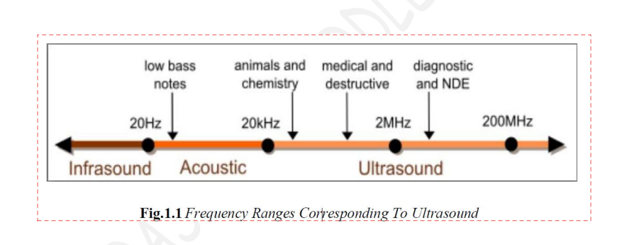

Ultrasound is used in many different fields. Ultrasonic devices are used to detect objects and measure distances. Ultrasonic imaging (sonography) is used in both veterinary medicine and human medicine. In the non-destructive testing of products and structures, ultrasound is used to detect invisible flaws. Industrially, ultrasound is used for cleaning and for mixing, and to accelerate chemical processes. Organisms such as bats and porpoises use ultrasound for locating prey and obstacles.

**Ultrasonics** is the application of ultrasound. Ultrasound can be used for medical imaging, detection, measurement and cleaning. At higher power levels, ultrasonics is useful for changing the chemical properties of substances.

A common use of ultrasound is in underwater range finding; this use is also called Sonar. An ultrasonic pulse is generated in a particular direction. If there is an object in the path of this pulse, part or all of the pulse will be reflected back to the transmitter as an echo and can be detected through the receiver path. By measuring the difference in time between the pulse being transmitted and the echo being received, it is possible to determine the distance. 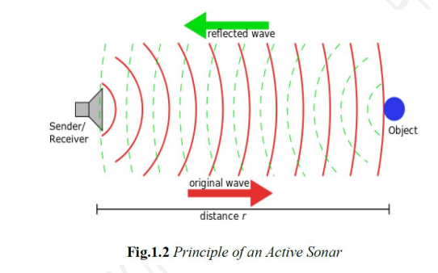

The measured travel time of Sonar pulses in water is strongly dependent on the temperature and the salinity of the water. Ultrasonic ranging is also applied for measurement in air and for short distances. For example hand-held ultrasonic measuring tools can rapidly measure the layout of rooms.

Although range finding underwater is performed at both sub-audible and audible frequencies for great distances (1 to several kilometres), ultrasonic range finding is used when distances are shorter and the accuracy of the distance measurement is desired to be finer. Ultrasonic measurements may be limited through barrier layers with large salinity, temperature or vortex differentials. Ranging in water varies from about hundreds to thousands of meters, but can be performed with centimetres to meters accuracy.

**4.2 Features of ultrasonic Wave**

1. Highly energetic

2. Their speed of propagation depends upon their frequency.

3. They can be transmitted over long distance without applicable loss of energy.

4. Intense ultrasonic radiation has disruptive effects on liquids by causing bubbles to be formed.

**4.3 Application of Ultrasonic**

1. Ultrasonic flaw detection.

2. Cutting and matching of hard material.

3. Ultrasonic soldering and welding.

4. Measuring of flow devices.

5. Application in medicine (Ultrasound).

6. Thermal Effect

7. Ultrasonic as a means of communication.

**4.4 A brief about application**

There are numerous practical applications for ultrasonic. The first widespread use was in underwater exploration. Ultrasonic waves proved to be an excellent method for determining the depth of water. Ultrasonic also are used to map the shape of lake and ocean floors. Submarines use ultrasonic waves to maintain secret contact with each other. In industry, ultrasonic waves have been used in the testing of machinery and machine parts. Using a narrow beam of ultrasound, engineers can look inside metal parts in much the same way that doctors use X rays to examine the human body. With ultrasonic technology, flaws in machinery can be detected and repaired without having to take them apart. Similar ultrasonic methods have been used to diagnose problems in the human body. As an ultrasonic beam passes through the body, it encounters different types of tissue such as flesh, bone, and organs. Each type of tissue causes the ultrasonic beam to reflect in a different way. By studying these reflections, physicians can accurately map the interior of the body. Unlike x rays, there is no risk of harmful overexposure with ultrasonic. Therefore, they have become a useful alternative to X rays for diagnosis and are often used on sensitive organs, such as kidneys, as well as to monitor the progress of pregnancies.

Because they can vibrate the particles through which they pass, ultrasonic waves are often used to shake, or even destroy, certain materials. An example of this procedure is ultrasonic emulsification. In this technique, two liquids that normally do not mix with each other (such as oil and water) are made to vibrate until they are blended. This technique is also used to remove air bubbles from molten metals before casting so that the finished piece will be free of cavities. Doctors use ultrasound to break up kidney stones and gallstones, thus avoiding invasive (cutting through the skin with a knife) surgery. Ultrasonic vibration also can be used to kill bacteria in milk and other liquids. Some inventors are attempting to perfect an "ultrasonic laundry," using high-frequency vibrations to shake dirt and other particles out of clothing.

**HARDWARE IMPLEMENTATION**

**5.EXPERIMENTAL SETUP AND RESULT ANALYSIS**

**HARDWARE COMPONENT**

The hardware components we used in this project are given below

5.1 ARDUINO UNO R3

5.2 ULTASONIC DISTANCE SENSOR {4-PIN}

5.3 PIEZO

5.4 LCD 16X2

5.5 10 K ohm POTENTIOMETER

5.6 VIBRATION MOTOR

5.8 BUZZER

5.9 CONNECTING WIRE

5.10 BREAD BOARD

**5.1 ARDUINO UNO R3**

The Arduino Uno R3 is a popular microcontroller board developed by Arduino.cc, based on the ATmega328P microcontroller. Known for its user-friendly interface, versatility, and robust functionality, the Arduino Uno R3 is widely used in educational, prototyping, and DIY electronics projects.

**Overview and Key Features**

The Arduino Uno R3, like the Arduino Nano, uses the ATmega328P microcontroller. It is larger than the Nano, making it better suited for projects that require more space and flexibility in component layout. The board includes 14 digital input/output pins (6 of which are PWM outputs), 6 analog inputs, a USB connection, a power jack, and a reset button. Unlike the Nano, the Uno R3 has a standard USB-B port for connecting to a computer, which also provides power. Additionally, it can be powered through an external power source connected via the DC power jack, supporting an input range of 7 to 12 volts for optimal operation.

**Communication and Programming**

Communication on the Arduino Uno R3 is straightforward and flexible. The ATmega328P chip supports UART (serial), I2C, and SPI communication protocols, enabling connections to a wide variety of peripheral devices. The RX and TX pins handle serial communication, allowing data to be transmitted between the board and other devices, including additional microcontrollers or computers.

Programming the Arduino Uno R3 is accomplished through the Arduino IDE, which offers an easy-to-use interface and supports various programming languages. Similar to the Nano, the Uno R3 comes preloaded with a bootloader, simplifying the upload of new code without requiring additional hardware. Users can program it over USB, using the Arduino IDE to select the board type and port, then upload code directly.

**Applications**

The Arduino Uno R3 is ideal for beginners and experienced users alike, as it supports a wide range of applications, including robotics, IoT projects, and simple automation tasks. Its flexibility, accessible programming, and extensive community support make it a top choice for a variety of project needs.

In summary, the Arduino Uno R3 is a versatile, reliable board that balances user-friendliness with powerful functionality, making it suitable for a range of electronics projects.

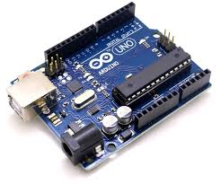

**5.2ULTASONIC DISTANCE SENSOR {4-PIN}**

The Ultrasonic Distance Sensor (commonly HC-SR04) is a popular 4-pin module used for measuring distance using ultrasonic sound waves. This sensor operates by sending an ultrasonic pulse and measuring the time it takes for the pulse to bounce back after hitting an object. It’s a widely used sensor in robotics, automation, and IoT projects, particularly in obstacle detection and distance measurement applications.

**Overview and Key Features**

The HC-SR04 Ultrasonic Distance Sensor consists of two main components: a transmitter and a receiver. The transmitter emits an ultrasonic wave, and the receiver listens for the echo. By calculating the time taken for the echo to return, the sensor determines the distance to the object. The 4-pin configuration includes:

* **VCC**: Power supply (typically 5V)
* **Trigger (TRIG)**: Input pin to initiate the ultrasonic pulse
* **Echo**: Output pin where the sensor provides a pulse to indicate the received echo
* **Ground (GND)**: Ground connection

**Working Principle**

The sensor works on the principle of **time-of-flight**. When a HIGH signal is sent to the TRIG pin, the sensor emits an ultrasonic wave at 40 kHz. The sensor then waits for the echo. The ECHO pin outputs a HIGH pulse whose duration represents the time taken by the sound wave to travel to the object and back. Using the formula:

**Distance=(Time × Speed of Sound)/2 ​**

we can calculate the distance, as the speed of sound in air is approximately 343 meters per second.

**Applications**

Ultrasonic Distance Sensors are versatile and commonly used in:

* **Obstacle avoidance systems** in robots and autonomous vehicles
* **Proximity alarms** and **security systems**
* **Level measurement** in tanks or containers
* **Parking sensors** in vehicles
* **People counting systems** in smart buildings

**Programming with Arduino**

The HC-SR04 can be easily interfaced with Arduino using basic digital I/O pins. Libraries like the New Ping library in Arduino make it simple to read the sensor’s data with minimal code. The sensor is programmed by sending a pulse to the TRIG pin and measuring the pulse duration from the ECHO pin.

In summary, the HC-SR04 Ultrasonic Distance Sensor is an effective and economical tool for non-contact distance measurement and is essential for projects that require distance sensing or obstacle detection.

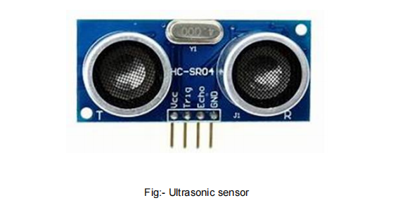

**5.3 Piezoelectric Sensor (Piezo)**

A **Piezoelectric Sensor** (or simply "Piezo") is a device that can detect mechanical changes in its environment, such as pressure, vibration, or force, by converting these into an electrical signal. This type of sensor operates based on the **piezoelectric effect**, where certain materials produce an electric charge in response to applied mechanical stress. Piezo sensors are used widely in applications that require precision in detecting vibrations, touch, or changes in pressure.

**Overview and Key Features**

A piezoelectric sensor typically consists of a small ceramic crystal material sandwiched between two metal plates. When this crystal is deformed or stressed, it generates a small voltage across the plates. This voltage can then be read by a microcontroller or signal conditioning circuit, providing information about the force or impact applied to the sensor. Key characteristics of a piezoelectric sensor include:

* **High Sensitivity**: Piezo sensors can detect very small changes in pressure or impact.
* **Rapid Response**: These sensors respond almost instantly to mechanical input, making them ideal for real-time applications.
* **Durability**: Piezo sensors are typically long-lasting and can withstand high levels of stress.

**Working Principle**

The piezoelectric effect is the core principle behind the piezo sensor’s operation. When mechanical pressure is applied to the piezo material, it displaces electric charges within the crystal structure, creating a voltage proportional to the applied force. This generated voltage can be captured and processed for various applications.

**Applications**

Piezoelectric sensors are used in a broad range of applications:

* **Vibration detection** in machines and structural health monitoring
* **Sound generation** in buzzers and alarms
* **Impact detection** in safety equipment like airbags
* **Precision measurement** in weighing scales and pressure sensors
* **Musical instruments** for pickup of sound vibrations

**Programming with Arduino**

A piezo sensor can be easily interfaced with an Arduino to read vibrations or impacts. The sensor output is often connected to an analog input on the Arduino, which can measure the voltage generated by the sensor when it detects a change. By interpreting this voltage, the Arduino can be programmed to perform actions in response to detected vibrations or pressure.

In summary, the piezoelectric sensor is a reliable and versatile tool for detecting mechanical changes and is valued in a wide range of applications, from consumer electronics to industrial machinery monitoring.

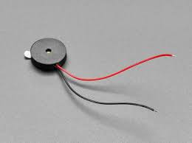

**5.4 LCD 16x2**

The **LCD 16x2** is a widely used **Liquid Crystal Display** module that can display text, numbers, and characters across two rows, with each row holding up to 16 characters, giving it a total display capacity of 32 characters. This display module is commonly used in microcontroller-based projects, including Arduino, Raspberry Pi, and other embedded systems, due to its simplicity and versatility.

**Key Features**

* **Resolution**: Displays **16 characters per line** over **two rows**. Each character is represented by a 5x8 dot matrix.
* **Driver IC**: Uses the **Hitachi HD44780** driver, which makes it compatible with many microcontrollers and facilitates ease of integration with the Arduino’s LCD library.
* **Backlight and Contrast Control**: The module has an LED backlight for better visibility, especially in low-light conditions. It also has a pin (V0) for adjusting the contrast of the display using a potentiometer.

**Pin Configuration**

The LCD 16x2 typically comes with a **16-pin configuration**:

1. **VSS** – Ground (0V).
2. **VCC** – Power supply (+5V).
3. **V0** – Contrast control, usually adjusted via a potentiometer.
4. **RS** – Register Select (0: Command, 1: Data).
5. **RW** – Read/Write (0: Write to LCD, 1: Read from LCD).
6. **E** – Enable pin, used to latch data present on data pins. 7-14. **D0-D7** – Data pins for communication in 4-bit or 8-bit mode.
7. **LED+ (Anode)** – Backlight power.
8. **LED- (Cathode)** – Backlight ground.

**Operating Modes**

* **4-Bit Mode**: Only **four data pins (D4-D7)** are used, saving microcontroller I/O pins. Data is sent in two steps, one nibble at a time.
* **8-Bit Mode**: All **eight data pins (D0-D7)** are used, allowing faster data transfer but requiring more I/O pins.

**Typical Connections with Arduino**

To use the LCD in a project with Arduino, connect the **RS, E, D4-D7, and V0** (for contrast) pins to corresponding Arduino pins, along with **VCC** and **GND** for power. The **Arduino LiquidCrystal library** simplifies controlling the LCD with functions like lcd.begin(16,2), lcd.print(), and lcd.setCursor().

**Applications**

The LCD 16x2 is widely used in projects needing text display for:

* **Sensor Readouts**: Displaying data like temperature, humidity, or distance.
* **Clocks and Timers**: Showing real-time information or countdowns.
* **Status Indicators**: Showing error messages, device statuses, and settings.

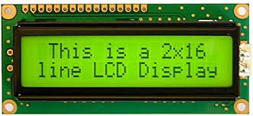

**5.5 10K Ohm Potentiometer**

A **10K Ohm Potentiometer** is a type of variable resistor that allows the user to manually adjust its resistance value within the range of 0 to 10,000 ohms. By rotating a knob, users can change the resistance and, as a result, control the amount of electrical current flowing through a circuit. This component is particularly useful for adjusting settings, such as contrast or brightness, in analog devices.

**Key Features**

* **Adjustable Resistance**: Provides a resistance range from 0 to 10K ohms, allowing for fine-tuning of electrical current in a circuit.
* **Three-Terminal Device**: Includes two terminals for the total resistance and a third terminal (the wiper) that outputs variable resistance based on the position of the knob.
* **Voltage Divider Functionality**: When used as a voltage divider, the potentiometer can output a proportionally adjusted voltage, which is commonly utilized in applications like sensor calibration or contrast control.

**Applications**

* **LCD Contrast Control**: Often used to adjust the contrast in LCD screens, allowing for clear visibility under different lighting conditions.
* **Analog Input Control**: Acts as an analog input in circuits, commonly seen in applications where variable inputs, such as light, sound, or temperature, need adjustment.
* **Volume and Brightness Adjustment**: Frequently used in audio and lighting circuits to control levels.

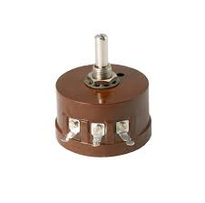

**5.6 Vibration Motor**

A **Vibration Motor** is a small electric motor that generates a vibration effect by rotating an unbalanced mass attached to the motor shaft. The motor’s rapid rotation of the offset weight creates vibration, making this component ideal for tactile feedback applications. Vibration motors are widely used in devices that need to provide silent notifications or alerts, like mobile phones and gaming controllers.

**Key Features**

* **Operating Voltage Range**: Generally operates between 3V and 5V, making it suitable for small battery-operated devices.
* **Types**:
  + **Coin Vibration Motors**: Thin, compact, and often used in smaller devices where space is limited.
  + **Cylindrical Vibration Motors**: Larger, cylindrical motors that can produce stronger vibration effects.
* **Low Current Requirement**: Requires minimal current, though it may need a transistor or MOSFET for control when used with a microcontroller.

**Applications**

* **Haptic Feedback**: Provides tactile feedback in user interfaces, often used in gaming controllers, wearables, and mobile devices.
* **Alert Mechanisms**: Used as a silent notification system for alarms or reminders in various devices.
* **Indicating System Events**: Provides sensory feedback for specific actions, such as sensor activation or event notifications.

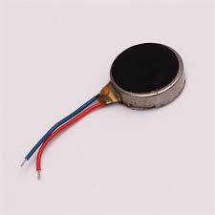

**5.8 Buzzer**

A **Buzzer** is an audio device that produces sound through rapid mechanical vibrations, typically generating beeps, alarms, or tones. It can either be an **active buzzer**, which has an internal oscillator to generate sound, or a **passive buzzer**, which requires an external signal to produce a tone. The buzzer is ideal for simple sound alerts in electronics projects.

**Key Features**

* **Types**:
  + **Active Buzzer**: Produces a continuous sound when powered, making it simple to use.
  + **Passive Buzzer**: Requires an external PWM signal, which enables control over the pitch and duration of the sound.
* **Operating Voltage**: Operates within a low voltage range, typically between 3V and 12V.
* **Frequency Control**: With a passive buzzer, varying the frequency of the input signal can change the tone, allowing for versatile sound output.

**Applications**

* **Alarm Systems**: Commonly used in security systems to alert users to potential issues.
* **Notifications**: Provides auditory feedback for user actions, such as button presses or system alerts.
* **Error Indications**: Signals error conditions or warnings in electronic devices and machinery.

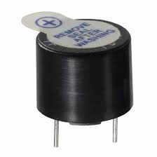

**5.9 Connecting Wires**

**Connecting Wires** are essential components for linking various parts of a circuit, enabling the transfer of electrical signals. They are especially useful in prototyping and experimental setups, where circuits are frequently modified or adjusted. Connecting wires allow for easy, flexible connections between components without the need for soldering.

**Key Features**

* **Types of Wires**:
  + **Male-to-Male**: Used for connecting components directly on a breadboard.
  + **Male-to-Female**: Used to connect modules or sensors with male headers to microcontrollers.
  + **Female-to-Female**: Often used for linking two male pin components or extensions.
* **Insulation and Flexibility**: Made of insulated, flexible material that comes in various colours for easy circuit identification and troubleshooting.

**Applications**

* **Prototyping**: Essential in prototyping circuits on a breadboard, allowing easy connections without permanent attachment.
* **Circuit Modification**: Useful in test circuits, where configurations are frequently changed.
* **Interfacing Components**: Enables flexible connections between microcontrollers and other components.

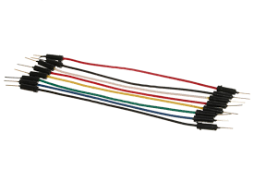

**5.10 Breadboard**

A **Breadboard** is a reusable platform for building, testing, and prototyping circuits without soldering. It consists of a grid of interconnected metal strips arranged into rows and columns, where components and wires can be inserted. This configuration allows easy connection and removal, making it ideal for experimenting and iterating on circuit designs.

**Key Features**

* **Power Rails**: Typically features horizontal power rails along the top and bottom, designated for connecting power and ground lines across the board.
* **Interconnected Rows and Columns**: The central section is divided into vertical columns (often 5 holes each), which are electrically connected, allowing components to share connections without soldering.
* **Reusability**: Components and wires can be easily added, removed, or repositioned, making the breadboard a versatile tool for rapid prototyping.

**Applications**

* **Circuit Prototyping**: Used to assemble and test circuits before permanent soldering, allowing for easy modification.
* **Educational Purposes**: Commonly used in labs and classrooms to teach students basic circuit assembly and design.
* **Debugging and Experimentation**: Aids in testing various configurations and troubleshooting circuit issues before finalizing designs.

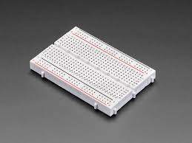

**CIRCUIT DIAGRAM**

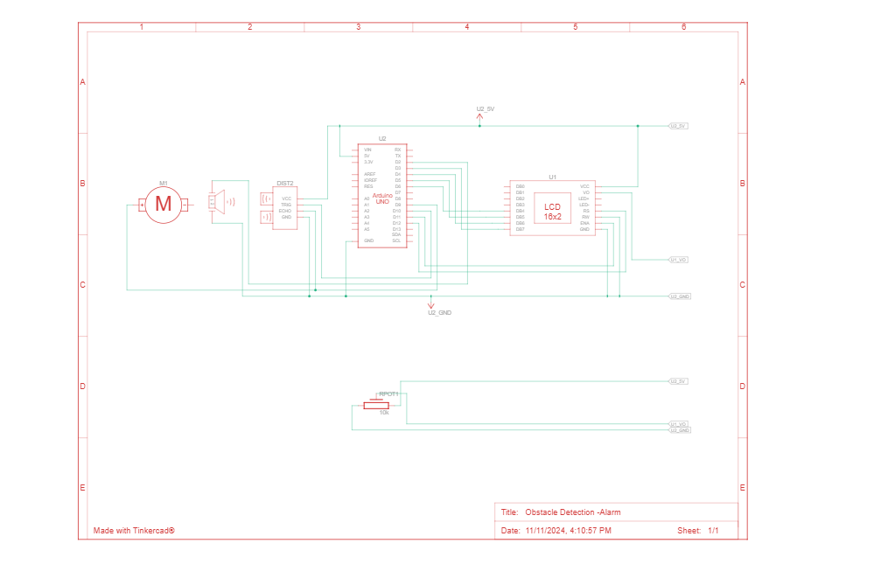

**TINKERCAD DIAGRAM**

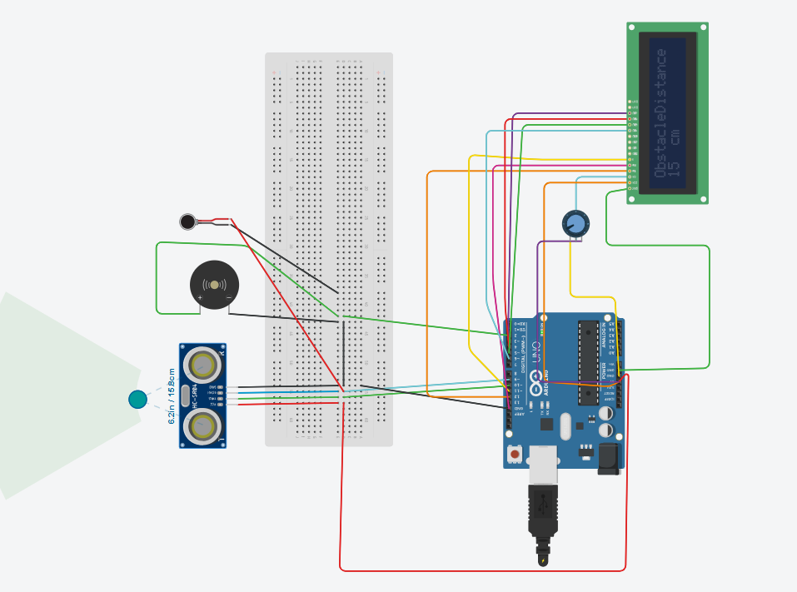

**6. CONCLUSIONS AND RECOMMENDATIONS**

**6.0 Introduction**

This chapter includes conclusion of the project, recommendation for any improvements in the project, and

the references.

**6.1 Conclusion**

The Obstacle detector system is effective when the right specifications of the components to be used are used. This make sure that the best results about the system are obtained, i.e. the sound, the Vibration should be effective.

If components used are not the right one for the system then it implies that the results obtained from our system will not be as exact as we required to be, hence making the system ineffective.

**6.2 Recommendations**

Before doing any project or this project concerning Arduino, the developer should at least be familiar with any programming language. I do recommend to future developers to attach more sensors especially those which can detect knee below obstacles Fire sensors and water sensors should be put on the cane too. Instead of using a 9 volts battery, a solar panel has to be attached because these people are found in far – places having less access to electricity or power sources.

**6.3 FUTURE SCOPE:**

In future with the advancement of quicker response of sensors, like the usage of top notch sensors it can be made highly useful and also the modules that one needs to wear as a bracelet or on any other part of the body can be transformed into a wearable clothing like a coat, so that it can be made fit for working and there can be more advancement in this device for instance we can use piezo electric plates in the shoes of the user which can generate sufficient electricity that the modules can run on.

**7.BIBLIOGRAPHY**

1. [**https://mrdvs.com/obstacle-detection-sensor/**](https://mrdvs.com/obstacle-detection-sensor/)
2. **Vidhya, D. S., Rebelo, D. P., D’Silva, C. J., Fernandes, L. W., & Costa, C. J. (2016). Obstacle detection using ultrasonic sensors. *IJIRST–International Journal for Innovative Research in Science & Technology*, *2*(11).**
3. **Vidhya, D.S., Rebelo, D.P., D’Silva, C.J., Fernandes, L.W. and Costa, C.J., 2016. Obstacle detection using ultrasonic sensors. *IJIRST–International Journal for Innovative Research in Science & Technology*, *2*(11).**
4. [**https://www.robotique.tech/robotics/obstacle-detection-system-with-arduino/**](https://www.robotique.tech/robotics/obstacle-detection-system-with-arduino/)
5. [**https://www.tinkercad.com/things/3oPjRfIR8Il-obstacle-detection-using-ultrasonic-sensor**](https://www.tinkercad.com/things/3oPjRfIR8Il-obstacle-detection-using-ultrasonic-sensor)
6. [**https://www.tinkercad.com/things/jnKPaBfKBYF-obstacle-detection-alarm-**](https://www.tinkercad.com/things/jnKPaBfKBYF-obstacle-detection-alarm-)